JFrog Artifactory:
What is Artifactory?
Artifactory is a repository manager created by JFrog. A repository manager is a dedicated server application designed to manage binary components for the application that we build.

In real life example imagine you are a chef working in a busy restaurant. You often need various ingredients like spices, herbs, and sauces to prepare delicious dishes. Now, instead of going to different stores to find each ingredient every time, wouldn't it be more convenient if you had a well-organized pantry where you can store all your ingredients?
In the world of software development, JFrog Artifactory is like that well-organized pantry for developers. It's a special tool that helps software developers store and manage all the important building blocks (like spices and sauces for a chef) needed to create software. These building blocks are called "artifacts" in the software world.
Artifacts can be things like code libraries, pre-built software pieces, or even entire applications. Instead of searching the internet or other places each time they need a artifact, developers can store them in Artifactory. This makes it easy to find and reuse these pieces for future projects.
Artifactory keeps everything tidy by organizing the artifacts in different sections, just like shelves in a pantry. It supports various types of artifacts used in different programming languages, so it can store all kinds of stuff!
How is JFrog differ from GitHub?
Git is where your source code resides. Git does all the version control because it can read plain text. Git cannot handle binary files which have no textual context. Although, I don’t want to include Git LFS which is a similar kind of thing, but let’s keep things simple as of now.

Now what to do if you want to handle your binaries? Then comes JFrog Artifactory which is the only universal solution which supports mostly all package managers available in the market. It can connect with your CI environment and do a lot more stuff than just managing your binary repositories.

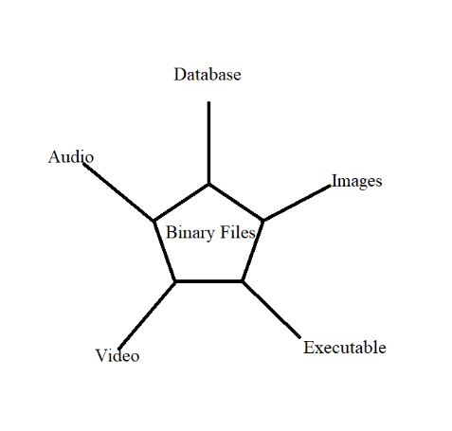
1. Images: Image files, such as JPEG, PNG, and GIF, are binary files used to store visual data like photographs, graphics, and icons.
2. Audio: Audio files like MP3, WAV, and AAC are binary files used to store sound data, such as music and spoken words.
3. Video: Video files like MP4, AVI, and MKV are binary files used to store moving images and audio together.
4. Executable: Executable files (EXE on Windows, and ELF on Linux) are binary files containing instructions that a computer's processor can directly execute, allowing them to run software programs.
5. Database: Database files are binary files used to store structured data, such as information in a spreadsheet, or a collection of records in a database.

What is JFrog?
JFrog is a software company that specializes in providing tools and solutions for software developers and DevOps teams. The company is best known for its flagship products, JFrog Artifactory and JFrog Bintray, which are widely used in the software development industry.
JFrog Artifactory: JFrog Artifactory is a universal artifact repository manager. It is designed to be a central hub for storing and managing binary artifacts such as libraries, dependencies, Docker images, and other software packages. Artifacts are critical components of the software development lifecycle, and Artifactory helps ensure their reliable storage, versioning, and distribution.
JFrog Bintray: Bintray was a distribution platform that allowed developers to publish, download, and share binary software packages. However, as of May 2021, JFrog announced that Bintray and related products, including JCenter, were sunset and would no longer be available for new sign-ups. Existing users were encouraged to migrate their packages to other platforms.
JFrog's products are popular among software development teams because they simplify the management of dependencies, artifacts, and the overall software release process. These tools play a crucial role in modern software development practices, enabling faster, more efficient, and reliable delivery of software to end-users.

Administration of JFrog
Under this

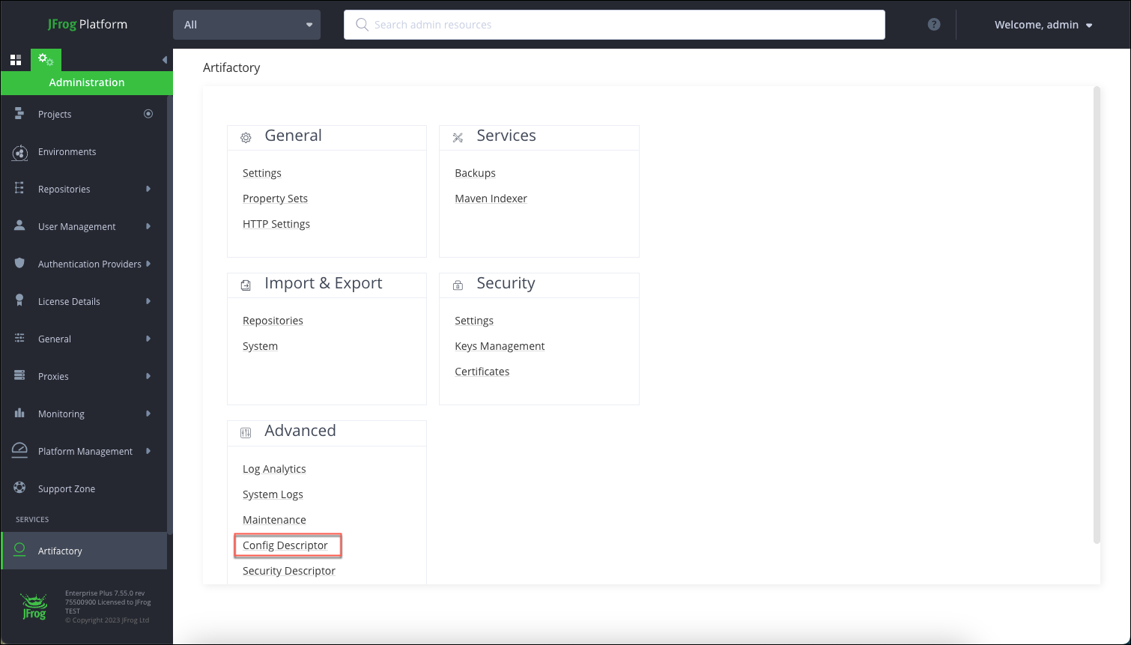

How to create a Project in JFrog?
Step 1: Login to JFrog Artifactory
Open your web browser and navigate to your JFrog Artifactory instance. Log in using your credentials.
Step 2: Accessing the Projects Page
Once logged in, find and click on the "Projects" link in the navigation menu. This will take you to the Projects page.
Step 3: Creating a New Project
On the Projects page, look for a button or link to create a new project. It might be labeled "Create New Project" or similar. Click on it to start creating a new project.
Step 4: Provide Project Details
You will be presented with a form to provide details for the new project. Fill in the required information, such as Project Name, Key, Description, and any other relevant fields.
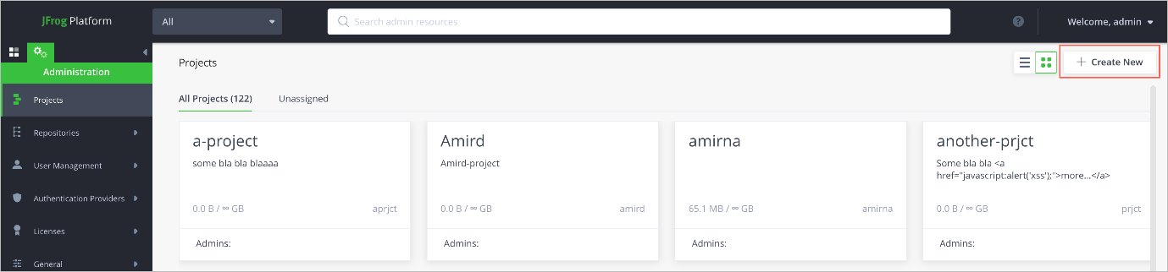
Step 5: Setting Permissions (Optional)
Depending on your Artifactory setup, you may have the option to set permissions for the project. You can specify which users or groups have access to this project and what actions they can perform within it.
Step 6: Save the Project
Once you have filled in the necessary details and set the permissions (if applicable), click the "Save" or "Create" button to create the project.
Step 7: Confirm Project Creation
After clicking the save button, you should receive a confirmation message indicating that the project has been created successfully.

Note: Whenever you create the Project in JFrog then Project Name should be Uppercase and same that name write in Project Key that should be in Lowercase. It is mandatory.
Suppose my Project name is YUVI and Project-Key is yuvi.
How to create a Repository in JFrog?
Creates a new repository in Artifactory with the provided configuration. Supported by local, remote, virtual, and federated repositories.
Repository is that place where you can see the storage of that artifact and files. So, we assign the repositories.
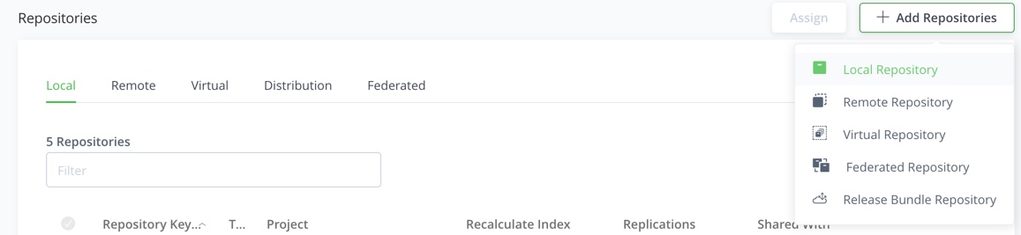

Step 1: Login to JFrog Artifactory
Open your web browser and navigate to your JFrog Artifactory instance. Log in using your credentials.
Step 2: Accessing the Repositories Page
Once logged in, find and click on the "Admin" tab or the gear icon in the top right corner to access the administration settings. Then, select "Repositories" from the dropdown menu. This will take you to the Repositories page.
Step 3: Creating a New Repository
On the Repositories page, look for a button or link to create a new repository. It might be labeled "Create Repository" or similar. Click on it to start creating a new repository.
Step 4: Select Repository Type
You will be presented with a list of repository types. Choose the type of repository you want to create based on your use case. For example, you can select "Local" for a repository that stores artifacts on your Artifactory server, "Remote" for a repository that proxies’ artifacts from external sources, or "Virtual" for a unified view of multiple repositories.
Step 5: Provide Repository Details
Next, fill in the required information to configure the new repository. The specific details you need to provide depend on the repository type you selected. For example:
For a Local repository: You will need to provide a unique key, repository name, and select a package type (e.g., Maven, npm, Docker, etc.).
For a Remote repository: You will need to specify the URL of the external repository you want to proxy and other settings as needed.
For a Virtual repository: You will need to select the repositories you want to include in the virtual repository.
Step 6: Set Repository Configuration (Optional)
Depending on the repository type, you may have additional configuration options to set up, such as specifying repository layouts, setting caching options, and defining repository settings for security and permissions.

Step 7: Save the Repository
Once you have filled in the necessary details and configured the repository settings, click the "Save" or "Create" button to create the repository.
Step 8: Confirm Repository Creation
After clicking the save button, you should receive a confirmation message indicating that the repository has been created successfully.
Note: Whenever you create the Repo you must choose the Package type by default, we are choosing the Docker package and our repository-key should write in this format yuvi-docker-dev-local and Environment-Key is DEV. By default, we choose Local or Virtual only.

Types of Repositories:
1. Federated Repo
In JFrog Artifactory, a federated repository (also known as a "Federated Repository Instance") is a feature that allows you to connect multiple Artifactory instances together in a distributed and interconnected manner. It enables you to create a network of repositories across different geographical locations or teams, providing a unified view and access to artifacts stored in these interconnected instances.
With federated repositories, you can have a central Artifactory instance (referred to as the "local instance") that is connected to one or more remote Artifactory instances (referred to as "edge nodes" or "remote instances"). Each remote Artifactory instance can belong to different teams or be in different locations, and they may have their own repositories and artifacts.
For Example: you have two big boxes of toys—one at your home and one at your friend's house. Now, wouldn't it be cool if you and your friend could easily share toys from both boxes without physically moving them back and forth?
In JFrog Artifactory, a federated repository is like a magical link between those toy boxes. It allows different Artifactory instances (think of them as the toy boxes) to connect and share their toys (artifacts) with each other.
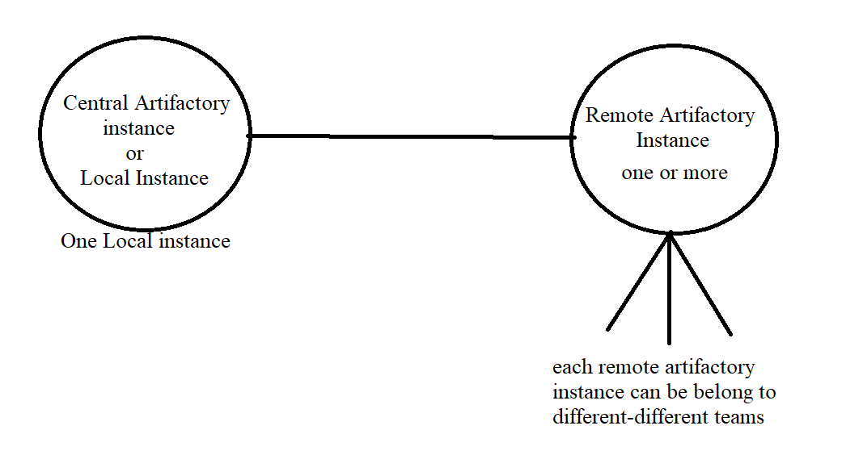
2. Remote Repo:
Remote repository (also known as a "Remote Repository Instance") is a special type of repository that is used to proxy and cache artifacts from external sources. It acts as a bridge between Artifactory and external repositories located on the internet or other remote servers.
For Example: Imagine you have a special helper (let's call them Arti) who can go to a big store far away and bring you all the toys you want. Instead of going to the store yourself, you just ask Arti, and they bring the toys to your home.
In JFrog Artifactory, a remote repository is like Arti, your helpful assistant. It acts as a helper that goes to a faraway place on the internet (an external repository) to get special things called "artifacts." These artifacts are like toys for developers—important pieces of code, software, and libraries they need for their projects.

3. Virtual Repo:
In JFrog Artifactory, a virtual repository (also known as a "Virtual Repository Instance") is a special type of repository that acts as a unified view of multiple other repositories. It provides a way to aggregate and access artifacts from one or more local and remote repositories under a single URL.
Imagine you have several different toy boxes in your house—one for Lego toys, another for action figures, and one more for board games. It would be convenient to have a magic box that combines all these toy boxes into one, making it easy to find and play with any toy you want, without having to search through each box separately.
4. Local Repo:
In JFrog Artifactory, a local repository (also known as a "Local Repository Instance") is a type of repository that stores artifacts directly on the Artifactory server. It acts as a local storage location for the artifacts generated or used within a specific organization or development team.
Imagine you have a special box in your room where you keep all your favourite toys. This box is your personal collection, and you can easily access and organize your toys whenever you want.

User Management:
User management in JFrog Artifactory involves controlling who can access the system, what actions they can perform, and what parts of the system they can interact with. It's like managing different roles for people in a team to ensure everyone has the right permissions and responsibilities.
How to create a New User?
In User Management this features under the Administrator, we see the column user you can create a New User.

Step 1: Login to JFrog Artifactory
Open your web browser and navigate to your JFrog Artifactory instance. Log in using your administrator credentials. You need to have administrative privileges to create new users.
Step 2: Accessing User Management
Once logged in, find and click on the "Admin" tab or the gear icon in the top right corner to access the administration settings. Then, select "Security" from the dropdown menu. This will take you to the Security settings page.

Step 3: Navigating to Users
On the Security page, you will see a list of options on the left-hand side. Find and click on the "Users" option to manage users.
Step 4: Creating a New User
On the Users page, look for a button or link to create a new user. It might be labelled "New User" or "Add User." Click on it to start creating a new user.
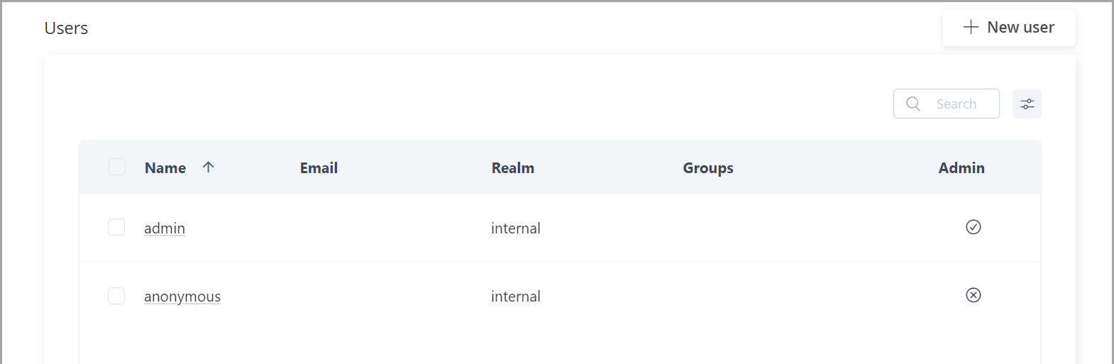
Step 5: Provide User Details
You will be presented with a form to fill in the details of the new user. You'll need to provide the following information:
Username: Choose a unique username for the new user.
Password: Set a password for the user. Optionally, you can set password policies if they are enabled in the system.
Full Name: Enter the full name of the user.
Email: Provide the user's email address.

Step 6: Assign User to Groups (Optional)
If you have created groups in Artifactory, you can assign the new user to one or more groups during the user creation process. This helps set permissions for the user more efficiently.
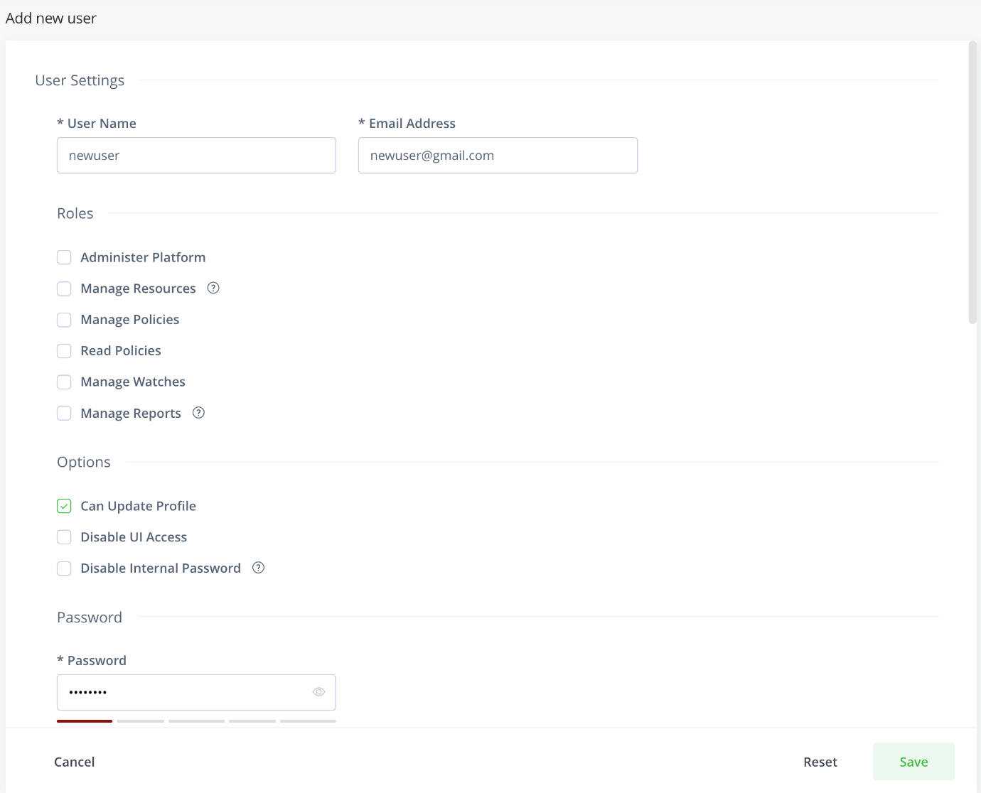

Step 7: Save the User
Once you have filled in the necessary user details and optionally assigned the user to groups, click the "Save" or "Create" button to create the new user.
Step 8: Confirm User Creation
After clicking the save button, you should receive a confirmation message indicating that the user has been created successfully.
For example: yuvi-svc-dev-user

How to create a New Group?
Step 1: Login to JFrog Artifactory
Open your web browser and navigate to your JFrog Artifactory instance. Log in using your administrator credentials. You need to have administrative privileges to create new groups.
Step 2: Accessing User Management
Once logged in, find and click on the "Admin" tab or the gear icon in the top right corner to access the administration settings. Then, select "Security" from the dropdown menu. This will take you to the Security settings page.
Step 3: Navigating to Groups
On the Security page, you will see a list of options on the left-hand side. Find and click on the "Groups" option to manage groups.
Step 4: Creating a New Group
On the Groups page, look for a button or link to create a new group. It might be labelled "New Group" or "Add Group." Click on it to start creating a new group.
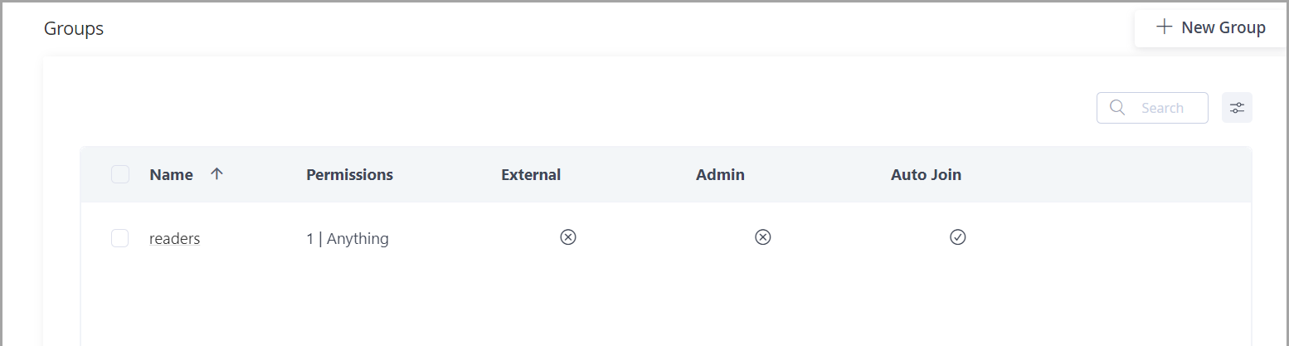
Step 5: Provide Group Details
You will be presented with a form to fill in the details of the new group. You'll need to provide the following information:
Group Name: Choose a unique name for the new group.
Description (Optional): Optionally, you can add a description to provide more information about the group's purpose.
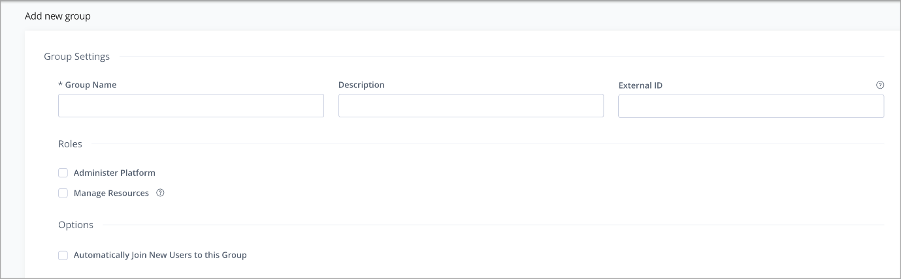

Step 6: Assign Users to the Group (Optional)
If you have already created users in Artifactory, you can assign one or more users to the new group during the group creation process. This helps in setting group permissions more efficiently.
Step 7: Save the Group
Once you have filled in the necessary group details and optionally assigned users to the group, click the "Save" or "Create" button to create the new group.
Step 8: Confirm Group Creation
After clicking the save button, you should receive a confirmation message indicating that the group has been created successfully.
Setting Groups for a User
You can assign and remove a user from groups when the user is created or by editing user's details later.
1. In the Administration module, under User Management | Users, from the list of users, select the user you wish to assign to or remove from the group.
2. In the Related Groups section of the form, you can set which groups the user should be assigned to.
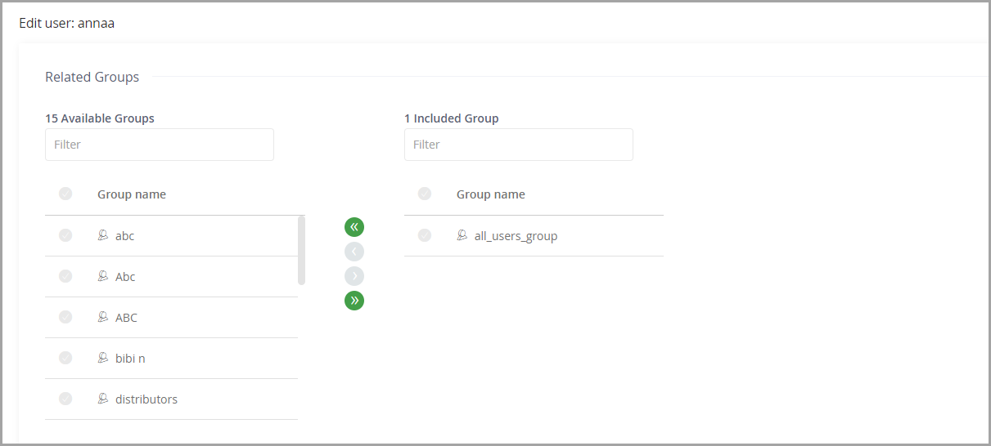

Setting Users for a Group
You can assign and remove a user from a group by editing the group's details.
1. In the Administration module, under User Management | Groups, from the list of groups, select the group you wish to modify.
2. In the Users section of the form, you can set which users should be assigned to the group.
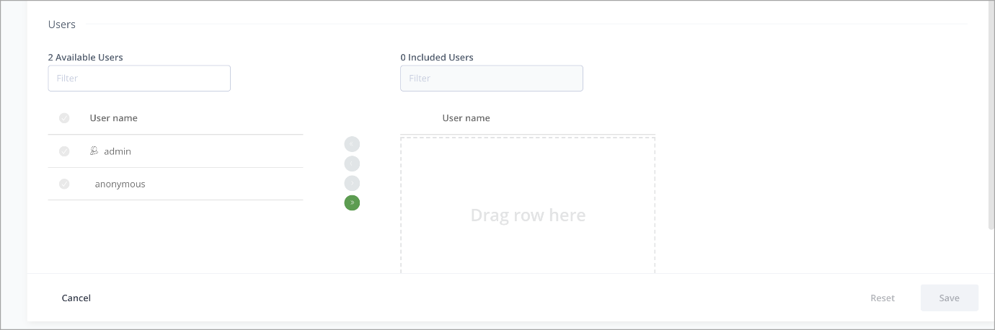

Roles:
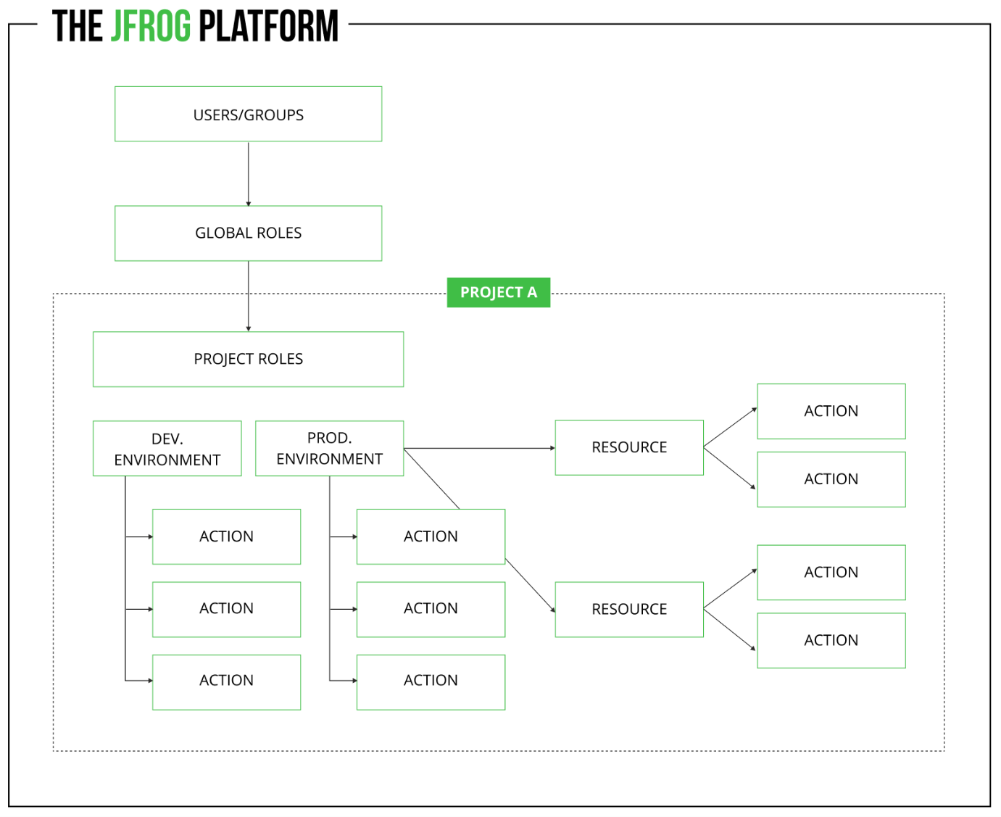
Basically, Role is classified in 2 ways.
1. Project Role.
2. Global Role.

What is Difference Between Project Role and Global Role?
Global Role: Global Roles are roles that are defined at the server level and apply across the entire Artifactory instance. These roles grant specific sets of permissions to users or groups that are valid for all repositories, projects, and configurations within the Artifactory server. Global roles are assigned by the Platform Admin and Global role-related procedures apply to all projects. Global roles cannot be renamed or deleted; however, the actions assigned to each role can be customized.
Project Role: Project Roles, on the other hand, are roles that are defined at the project level. A project in Artifactory represents a specific software project or codebase. Project Roles are used to manage permissions within a specific project, restricting or granting access to certain users or groups for that project only. whereas Project roles are project-specific and comprise of Global and Project roles and Project roles are defined by a Project Admin role.

Create a Global Role:
Step 1: Login to JFrog Artifactory
Open your web browser and navigate to your JFrog Artifactory instance. Log in using your administrator credentials. You need to have administrative privileges to create or edit Global roles.
Step 2: Accessing User Management
Once logged in, find and click on the "Admin" tab or the gear icon in the top right corner to access the administration settings. Then, select "Security" from the dropdown menu. This will take you to the Security settings page.
Step 3: Navigating to Global Roles
On the Security page, you will see a list of options on the left-hand side. Find and click on the "Global Roles" option to manage Global roles.
Step 4: Creating a New Global Role
On the Global Roles page, look for a button or link to create a new Global role. It might be labelled "New Global Role" or "Add Role." Click on it to start creating a new Global role.
Step 5: Provide Role Details and Permissions
You will be presented with a form to fill in the details of the new Global role. You'll need to provide the following information:
Role Name: Choose a unique name for the new Global role.
Description (Optional): Optionally, you can add a description to provide more information about the role's purpose and permissions.
Next, you can assign permissions to the Global role. Select the permissions you want to include in this role from a list of predefined permissions. These permissions determine what actions users or groups with this Global role will be able to perform across the entire Artifactory instance.
Step 6: Save the Global Role
Once you have filled in the necessary Global role details and assigned the desired permissions, click the "Save" or "Create" button to create the new Global role.
Edit an Existing Global Role:
If you want to edit an existing Global role, follow these steps:
Step 1: Navigate to Global Roles
Access the Security settings as described above, and then click on "Global Roles" to see the list of existing Global roles.
Step 2: Locate the Global Role
Find the Global role you want to edit from the list.
Step 3: Edit the Global Role
Click on the Global role's name or the "Edit" button next to it. This will allow you to modify the Global role's name, description, and permissions.
Step 4: Save the Changes
After making the necessary edits, click the "Save" or "Update" button to save the changes to the Global role.

Create a Project Role:
Step 1: Login to JFrog Artifactory
Open your web browser and navigate to your JFrog Artifactory instance. Log in using your administrator credentials. You need to have administrative privileges to create or edit Project roles.
Step 2: Accessing User Management
Once logged in, find and click on the "Admin" tab or the gear icon in the top right corner to access the administration settings. Then, select "Security" from the dropdown menu. This will take you to the Security settings page.
Step 3: Navigating to Project Roles
On the Security page, you will see a list of options on the left-hand side. Find and click on the "Project Roles" option to manage Project roles.
Step 4: Creating a New Project Role
On the Project Roles page, look for a button or link to create a new Project role. It might be labelled "New Project Role" or "Add Role." Click on it to start creating a new Project role.
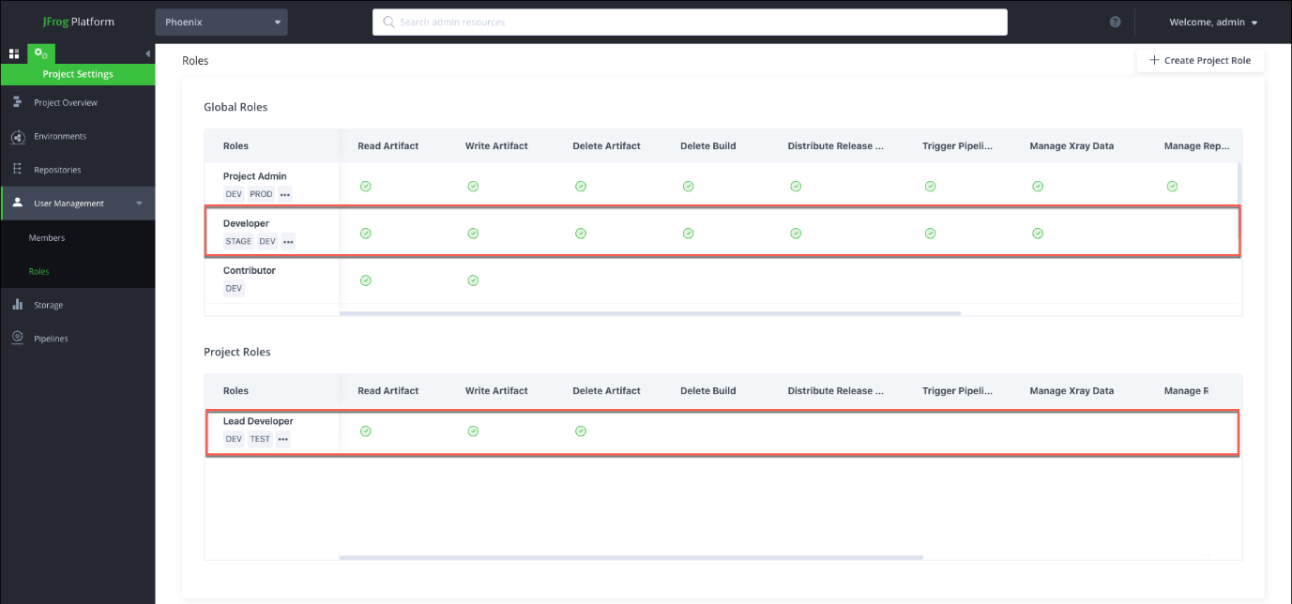
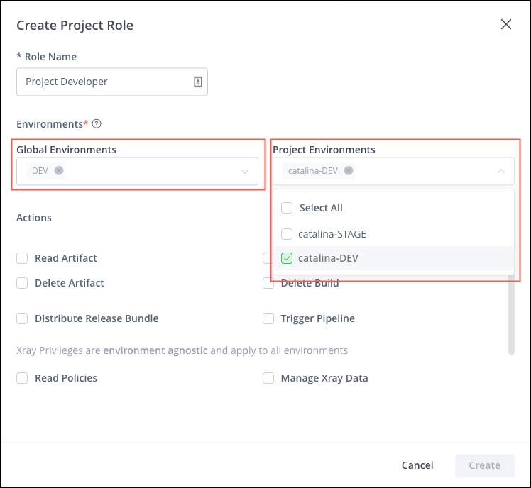

Step 5: Provide Role Details and Permissions
You will be presented with a form to fill in the details of the new Project role. You'll need to provide the following information:
Role Name: Choose a unique name for the new Project role.
Description (Optional): Optionally, you can add a description to provide more information about the role's purpose and permissions.
Next, you can assign permissions to the Project role. Select the permissions you want to include in this role from a list of predefined permissions. These permissions determine what actions users or groups with this Project role will be able to perform within the specific project.
Step 6: Save the Project Role
Once you have filled in the necessary Project role details and assigned the desired permissions, click the "Save" or "Create" button to create the new Project role.
Edit an Existing Project Role:
If you want to edit an existing Project role, follow these steps
Step 1: Navigate to Project Roles
Access the Security settings as described above, and then click on "Project Roles" to see the list of existing Project roles.
Step 2: Locate the Project Role
Find the Project role you want to edit from the list.
Step 3: Edit the Project Role
Click on the Project role's name or the "Edit" button next to it. This will allow you to modify the Project role's name, description, and permissions.
Step 4: Save the Changes
After making the necessary edits, click the "Save" or "Update" button to save the changes to the Project role.

Xray:
Under this Xray feature there are 2 types of features.
1. Indexed Resources
2. Watches & Policies

1. Indexed Resource:
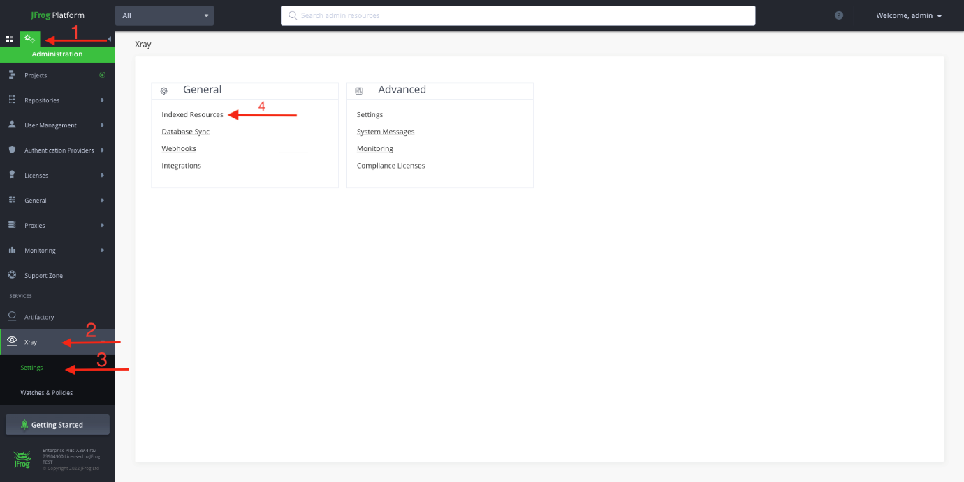
Indexed Resources in JFrog Xray are like a big library where Xray keeps track of all the software parts you use to build your applications. Just like a library has information about each book, Xray knows details about each software piece, like what it does and where it comes from.
Xray checks these software parts to see if they have any security problems or if they follow the right rules for using them. It's like making sure the ingredients you use for cooking are safe and don't cause any issues.
Whenever you add new software pieces to your projects, Xray scans them right away to see if there are any known problems or if they match the right rules. It's like checking if any new books added to the library are safe to read.
If Xray finds any issues, it tells you right away so you can fix them and use your software safely. Just like a librarian alerts you if there's a problem with a book, Xray alerts you about any problems with your software pieces.
In summary, Indexed Resources in Xray is like a helpful librarian that keeps an eye on all your software pieces, ensuring they are safe and following the right rules for your software projects.

2. Watches & Policies:
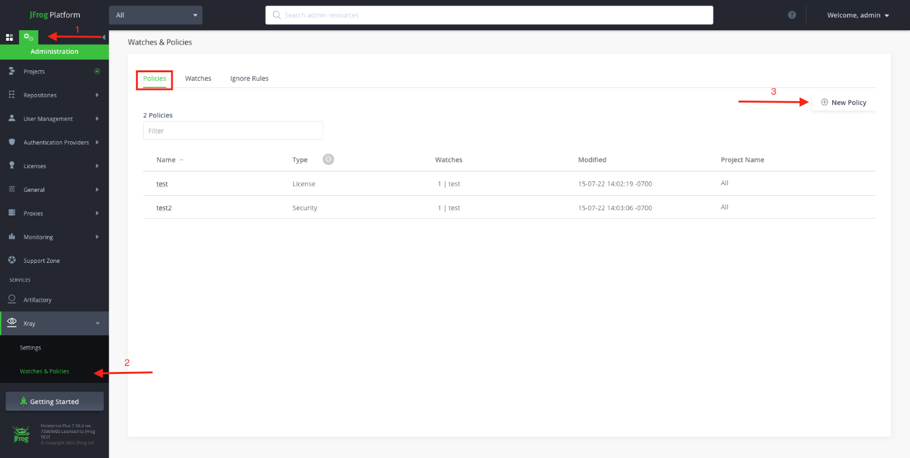

Policies in Xray:
1. Policies are like rules you set up to make sure your software is safe and follows the right guidelines.
2. You can create your own rules or use ready-made ones from Xray.
3. These rules tell Xray what to look for in your software, like security issues or license problems.
3. If Xray finds any problems, it will let you know and can take actions to fix them automatically.
Watches in Xray:
1. Watches are like special alerts that you set up to keep an eye on specific parts of your software.
2. You can create a watch for a certain software package, library, or even a whole project.
3. Whenever Xray sees any issues with the watched parts, it sends you a notification or alert.
4. This helps you quickly find out about any potential risks or problems and take action to fix them.

